x

Emcure NPD

**PHASE 2 DOCUMENT**

June 29, 2023

NeoSOFT is a SEI-CMMI Level-5 Global IT Consulting & Software Solutions Provider

|  |  |
| --- | --- |
| **Document Control Sheet** | |
| **Current Version** | 1.3 |
| **Project Code** | NS_Emcure_29_06_2023 |
| **Project Name** | Emcure NPD Phase 2 |
| **Document Type** | Milestone Document |
| **Author** | Nilesh |
| **Sales Person** | Saumil Shah |
| **Frequency of Document Review** | Next Revision of Standard Documents |
| **Document Creation Date** | 29-06-2023 |
| **Last Updated Date** | 14-July-2023 |

|  |  |  |  |
| --- | --- | --- | --- |
| **Revision History** | | | |
| **Version** | **Date** | **Name** | **Comments** |
| 1.1 | 29-06-2023 | Nilesh | Milestone Document |
| 1.2 | 07-07-2023 | Nilesh | Milestone Document |
| 1.3 | 14-07-2023 | Nilesh | Milestone Document |

**Emcure NPD Phase 2**

**Milestone 1 - Epic 1**

1. PIDF
   1. Reference product detail & API sourcing block which we have hidden as per Rahul Patil request but now as mentioned by SID, we would need those again. **-> Done**
   2. InHouse field which we have hidden as per Rahul request we would need those again and will be utilized for PBF costing (In House or Out Sourced) **-> Done**
   3. Every business unit will be able to see PIDF request in list and then they can edit the records. There will be further new business logic for different business units. **-> Done**
      1. Form will have radio button (Every business unit user have to fill this up **-> Done**
         1. Interested
         2. Not Interested
      2. If its interested than every business unit need to select the Region and Countries for which it is going to be interested **-> Done**
      3. After filling region and country **-> Done**
         1. They can update the PIDF form and it will be for their specific business unit only
   4. Here they can not change “Dosage Form, Dosage Type, Molecule Name & In House” apart from that, user can change anything and that will be saved respective to their business unit. - **-> Done**
   5. PIDF request can not be approved for 15 days or until all business unit provide their response “Interested / Not Interested”. **->Done** 
      1. Once PIDF Request is approved after that no business unit can select Interested / Not Interested. **-> Done**
   6. Once PIDF request is approved it will be process further for those business unit only who marked this as Interested. **-> Done**
   7. Need to add 2 more new field into PIDF **-> Done**
      1. Trade Name Required (Boolean) yes / no
      2. Trade Name Date Registered (It will display only when Trade Name says Yes)
2. IPD Form Changes
   1. We will have all the business units which is active in the system **-> Done** 
      1. Form will be enabled for only those business units says interested, for other business unit form will not be there we will have note: “{BusinessUnit} have said not interested on {DateTime} by {User}”. OR {BusinessUnit} have not taken any action on this.
   2. Patent Details for Formulation & API
      1. This data should be Country specific so we need to add new column country where every patent details will be as per country. **-> Done**
      2. All the countries for business unit should auto come which user have selected while saying interested in PIDF. **-> Done**
      3. We will have below more fields in this child form **-> Done**
         1. Country
         2. Patent Strategy (Dropdown) These will fetch from db table, but master is not required in this scope.
            1. Other option will be there in dropdown, if that is selected than we need to give textbox to enter value
         3. Patent Type (textbox)
         4. Basic Patent Expiry (Date field)
         5. Other Lmiting Patent Date 1 (Date field)
         6. Other Lmiting Patent Date 2 (Date field)
         7. Earliest Launch Date (Date field)
         8. Any Patents to be Filed (Boolean field)
         9. Earliest Market Entry (Date field)
         10. Estimated Number of generics in the market (textbox)
         11. Law firm being used (textbox)
3. PBF Module Changes
   1. We will have all the business units which is active in the system **-> Done**
      1. Form will be enabled for only those business units says interested, for other business unit form will not be there we will have note : “{BusinessUnit} have said not interested on {DateTime} by {User}” OR {BusinessUnit} have not taken any action on this.
   2. We need another tab “RA” which will have below fields and data will be specific to countries. **-> Done**
      1. Country
      2. Pivotal batch manufactured
      3. Last data from R&D
      4. BE Final Report
      5. Type of Submission
      6. Dossier Ready Date
      7. Earliest Submission - D Excl
      8. Earliest Launch - D Excl
         1. As per selection of some parameters / fields this value will auto come, it have different selection and period
      9. Last date to regulatory (Date)
      10. Note: There are couple of field which should be come auto as per selected options, so date will be auto calculated from the entered field values **-> Done**
      11. Note: Countries should auto come as per interested countries in PIDF **-> Done**
   3. Enhance the UI for PBF form in terms of usability, we can use tabs and next button click to save the data **-> Pending**
   4. General Tab New Fields **-> Done**
      1. R&D Responsible person (Textbox)
      2. Type of development (Date)
      3. Pivotal batches manufactured completed (Date)
      4. Stability Results
         1. Day 0 (Date)
         2. 3 months (Date)
         3. 6 months (Date)
      5. Some more fields would be required as mentioned below, those are not mandatory fields**-> Done**
      6. 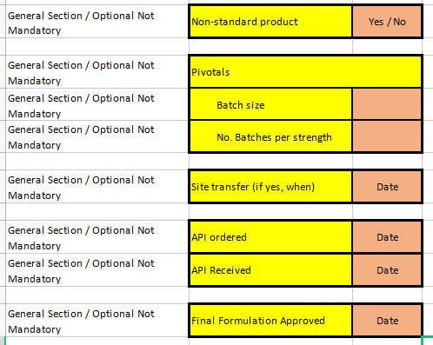
      7. Below form would be required to fill data, user will enter into textbox and save the data **-> Pending**
      8. 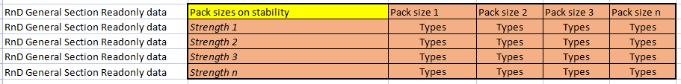
   5. Clinical Tab New Fields **-> Done**
      1. BE Study Results (Date from Bio tab)
   6. While filling PBF data we will display only those strength which is applicable for selected business unit. **-> Done**
4. Commercial Module Changes
   1. We need to remove feature of Interested / Not Interested which we have developed as per Rahul Patil request. **-> Done**
   2. We will have all the business units which is active in the system **-> Done** 
      1. Form will be enabled for only those business units says interested, for other business unit form will not be there we will have note : “{BusinessUnit} have said not interested on {DateTime} by {User}” OR {BusinessUnit} have not taken any action on this.
5. API Management
   1. API IPD **-> Done**
      1. Data for Patent details will be displayed as per region and country
   2. API RnD **-> Done**
      1. Data for Patent details will be displayed as per region and country
6. Project Management (POST PIDF)
   * 1. What ever the workflow has been selected into PBF form (In House) OR Commercial Form (Out Source) according to that set of tasks should get auto created and will be displayed into Gantt and Task list. **-> Done**
   1. As of this milestone we will have 2 workflow, one is for Tillomed and another is for Global, we need to have support for this to create tasks. . **-> Done**
7. Outsourced /In-licensing products
   1. If we have this option selected while creating PIDF than we will have different impact
      1. PBF -> Request will not be visible in PBF form since we are not making product in house. **-> Done**
      2. Commercial **-> Done**
         1. We need additional Tab where option to fill Cost & timeline (Its more or less PBF data, which will be later utilized into PBF Charter)
            1. It will have 2 dropdown at initial level

Project Management Workflow

It will be selected here, according to that it will create tasks in project management

PBF Charter Workflow

By selection of that auto title & timeline will be populated.

User can remove any row or add new row for that data.

1. Master Management
   1. Workflow for Project Management (As of now we need table only, screen can be developed later in next milestone) **-> Done (Master_Workflow)**
   2. Workflow for PBF Cost (Outsource) (As of now we need table only, screen can be developed later in next milestone) **-> Done (Master_PBFWorkFlow)**
   3. Masters to manage for RnD (As of now we need table only, screen can be developed later in next milestone)
      1. Type of submission **-> Done (Master_TypeOfSubmission)**
      2. National Approval **-> Done**
      3. Workflow for different dates **-> Pending (Hide for now, because we need to get details from business)**

**Milestone 1 - EPIC 2**

1. PIDF
   1. Once PIDF is submitted, we need to send reminder everyday to all the different business unit users who have access to PIDF module. It will be for let them mark, interested / Not interested. **-> Done**
      1. SP need to review for this **-> Done**
   2. PIDF details can be edited until Finance approved the same, since user can extend the countries while filling commercial details, so we should have option to edit the record in PIDF until Finance get approved. Note: Approval of PIDF will not be required in case of extension of countries -> -- That feature will be implemented on commercial screen
2. IPD Form Changes
   1. IPD details can be edited until Finance approved the same, since user can extend the countries while filling commercial details, so we should have option to edit the record in IPD until Finance get approved. Note: Approval of IPD will not be required in case of extension of countries -- That feature will be implemented on commercial screen
3. PBF Module Changes
   1. In PBF we should have option to Reject the request, if user rejected from here, this complete project will get rejected (Requested by Mr. Uday Potdar & SID) (This option will be there for if any molecule which can not be developed due to technical issues than request can be rejected) **-> Pending**
   2. TDP (Trade Dress Proposal) - New section required under the general tab, this form will be completely editable and user will be able to enter all the details and we need to save those. **-> Pending**

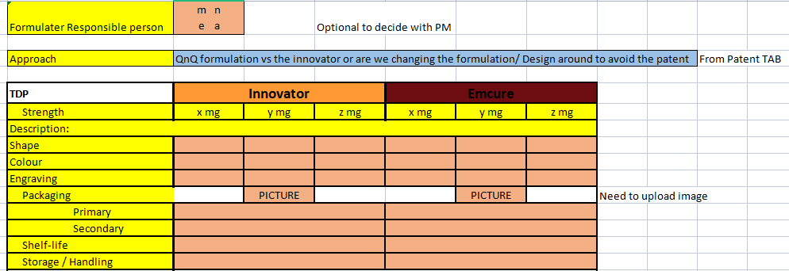

* 1. PBF charter should be business unit specific and we can have multiple in case of one molecule, if strength are different for business units. **-> Need discussion**
  2. We need to display data of Type of submission, National Approval & Dates in read only format, just for user to see logic begin the earliest launch date -**-> Done**

1. Commercial Module Changes
   1. We need to have another layer/tab for the country, where strength will be displayed as per country and further level / operation will be same. So eventually we will have data for every business unit -> Country -> Strength -> Pack Size -> Year Data.
   2. In this module we need additional feature to extend interested countries so user can select more countries interested than what they actually selected when they shown interest in PIDF --> **Need to discuss**
      1. It will effect on PIDF & IPD both screens since its reverse feature
         1. IPD form will be editable to submit the data for new countries
         2. PIDF form will be editable for submit the data for new countries
   3. Commercial year data --> Target cost of good (decimal field) need to be add into popup **-> Done**
   4. Commercial year data, initially discussed to add for 3 years now we need to add for 5 years. **-> Done**
   5. Currently we have one scheduler which send reminder everyday to those users who have access of commercial module, it will send to those users only who said interested or not taken any action.
      * 1. Now we need to change in logic again where reminder will be send to business unit who said interested while PIDF and this reminder frequency will be once in a week -**-> Pending**
2. API Management
   1. If user select API Not Interested than User will have a form in the same popup, These are the fixed properties and it wont be dynamic**-> Done**
   2. 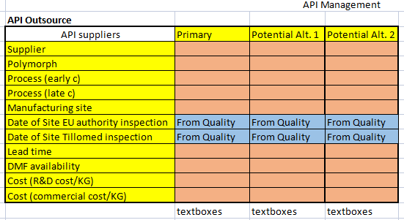
      * 1. As per this scope we only need to capture this data, we do not need to display it any where. We will consider this in next milestone.
   3. If user select API Interested than User will have a form in the API RnD section, These are the fixed properties and it wont be dynamic**-> Done**
   4. 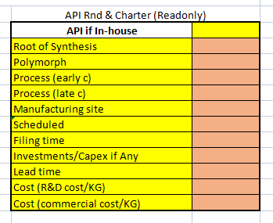
      1. This filled data we need to present in API charter summary in readonly fields.
3. Finance Management
   1. We do not required any country mapping in Batch wise costing section **Done**
   2. We will have all the business units which is active in the system **Done**
      1. Form will be enabled for only those business units says interested, for other business unit form will not be there we will have note : “{BusinessUnit} have said not interested on {DateTime} by {User}”
   3. We will have all the strength from different country and business unit in one dropdown
   4. COGS will be same in case of one SKU and pack size (for different business unit) only market share and NSP are going to change as per entered in commercial for different business unit **Need to discuss**
   5. Finance Charter **Need to discuss**
      1. We need feature to see summary as per business unit and country
      2. We need feature to see summary as per business unit and all the countries.
   6. Currently for One SKU and Pack size we are getting some data from commercial, these data we are getting from the commercial (In commercial those are year specific), as of now we are fetching fist year data for that SKU and pack size and use for display and calculation. As discussed with SID this is correct and no changes required.
4. Budget Approval
   1. In case of different strength available for business unit, we will have different charter. If we will have same strength than we will have one charter. **Need to discuss**
   2. Finance Charter
      1. We need feature to see summary as per business unit and country
      2. We need feature to see summary as per business unit and all the countries.
      3. We need feature to see summary for all business unit (consolidated)
         1. Till Cumulative cash flow all the data will be sum but after that all values will be calculated from upper values only, so sum will not happen there.
   3. By Default Finance Charter should be selected as active one **Done**
   4. We need to add another data to display on this screen **Need to discuss**
      1. Market
      2. Launch Year
      3. Country wise summary
         1. 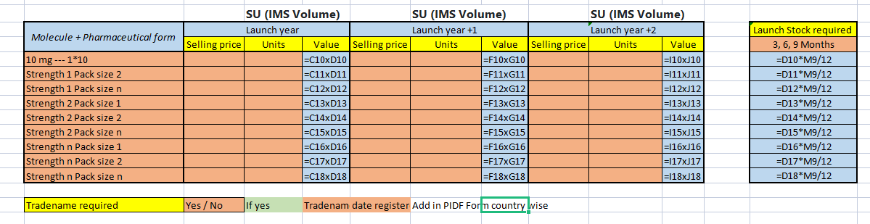
   5. Wishlist Module -**-> Done**
   6. This will be simple form where we will manage CRUD operations. This data will not be utilized any where. **Need to discuss**
      1. Type drop down These will fetch from db table, but master is not required in this scope.
      2. We will utilize this data later -> Its out of scope for now.
      3. 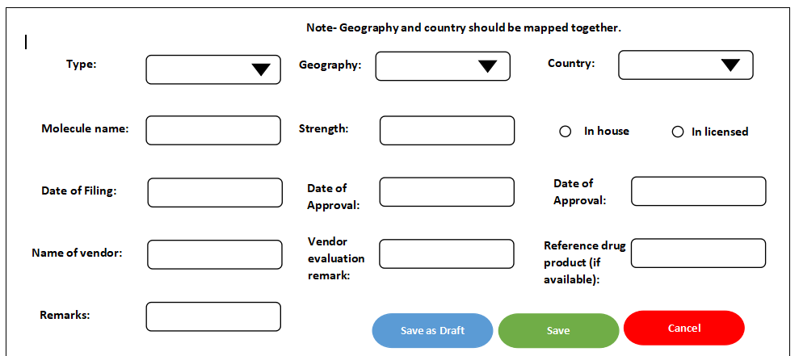
5. Outsourced /In-licensing products
   * 1. PBF Charter (Budget Approval Screen)
        1. We will present the data in same format as we are entering details, since there are no format available as of now. **Pending**

**Milestone 1 - EPIC 3**

1. For one time exercise requesting is the new launches tool file format which we will fill as per our new tool requirement considering new field additions
   1. We need to have upload excel file for all steps at PIDF process, where all the data will be uploaded.
   2. Excel format will be prepared by NeoSOFT, which will be as per new developed system.
   3. Emcure team will add data in those Excel format provided by NeoSOFT and upload file. It will import all the data into system. All these data will be pre approved since those are existing data and pre approved only.
   4. We will upload one PIDF request at a time in excel file, if there are 100 PIDF than user will upload 100 Excel file or select multiple files to upload.
      1. Excel upload PIDF Management
      2. Excel upload IPD Management
      3. Excel upload Medical Management
      4. Excel upload Commercial Management
      5. Excel upload PBF Management
      6. Excel upload Finance Management
      7. Excel upload API Management
      8. Task Creation / Migration in Project Management which will happen auto

**Milestone 2**

1. Different summary on screens
   1. Commercial Module
      1. 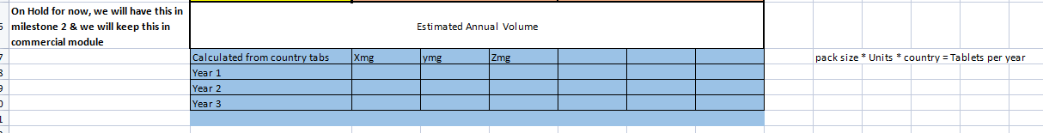
2. Reports